Legal Information Technology Instructions Spam Rule
Office 365

- Open Internet Browser  - Go to https://www.office.com/  - Click Sign in  - Enter your cougarnet information to login  - Click on Outlook App | 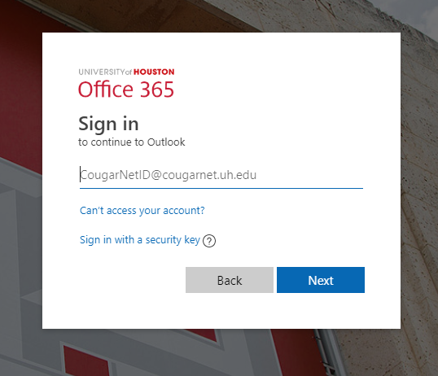
- Click on Setting (top right of window)

- Click on new rule, then choose under add a condition and select subject and body includes.  - Type on the next box “spam”  - Click on the save bottom. | 